Safety Alert

Electric Shock from Light Switch

Details of the Incident
A delivery driver visiting a site suffered an electric shock as he went to turn on a light switch, fortunately he avoided serious injury. The metal switch box was located in an area below the processing plant where the previous day a pressure washer was used for cleaning. The pictures below show that dirt had accumulated on the switch as a result of the overhead cleaning activities such as washing down. The resultant build up meant that moisture was retained around the switch leading to electricity tracking to the outside of the switch box.

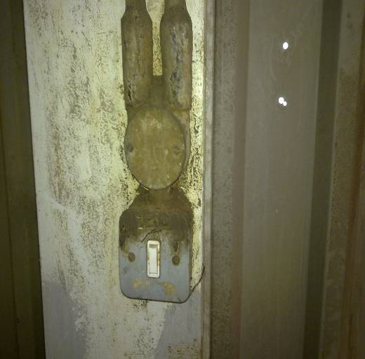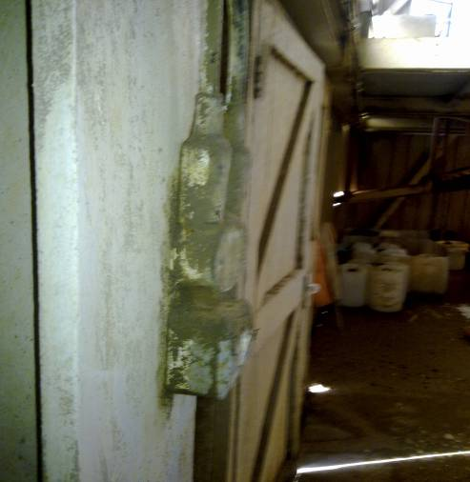

Learning Points
The metal switch box was inappropriate for the environment it was located; the switch should have been protected or relocated to a different area. Inspection and maintenance schemes should identify where activities are causing damage to equipment. Risk assessment should identify where water and electricity have the potential to come into contact and design of electrical systems must ensure they are protected from moisture ingress where necessary.

- Risk Assessment – Are all electrical systems protected from the potential for moisture ingress? Is the right electrical equipment used in the right environments? Where pressure washers or hoses are used are precautions taken to protect electrical equipment?
- Inspection & Maintenance – Do inspection schemes identify where damage is caused by activities? Are common items like light switches included in inspection schemes?

REMEMBER ELECTRICITY CANNOT BE SEEN AND IT KILLS

